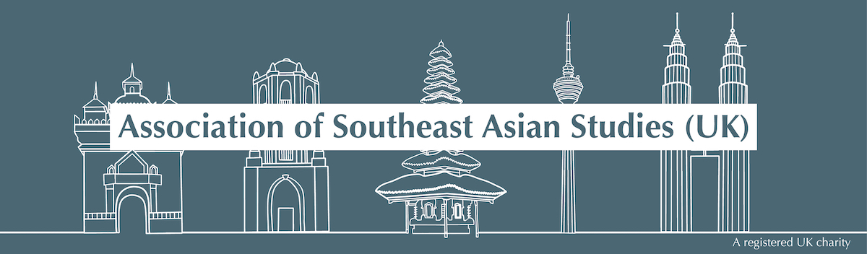

RESEARCH IMPACT AWARD 2026 GUIDANCE NOTES

Eligibility
- Applicants can be based anywhere in the world but must be members of ASEAS and working at postgraduate level or above, conducting their own programme of research.
- Awards cannot be made retrospectively.

Types of projects funded by the Research Impact Award
- Fieldwork in Southeast Asia or key sites in the diaspora;
- Research visits to important regional archives, museums, collections, exhibitions or performances (concerning but not necessarily located in Southeast Asia);
- The hiring of a research assistant to consult archives remotely or the purchase of an individual subscription to an online resource database;
- A visit to engage in collaborative work (for example, writing, artistic practice or the development of a digital project) with an academic or practitioner colleague from another institution in Southeast Asia;
- The development or dissemination of a film, audio piece, website, or other artistic project in order to communicate research to a non-academic audience;
- Delivery of a paper to an academic or practitioner audience based on research previously conducted on/in the region.

Terms of Application
- Applications must be submitted as a PDF document to awards@southeastasianstudies.org by midnight on the closing date of 27 March 2026.
- Applications should state the nature, aims, and methods of the project being proposed including: the sites to be visited; persons taking part (so far as this is known); the expected duration; anticipated costs (detailed budget); the anticipated outputs (publications and others); and should indicate how the research advances Southeast Asian studies generally.
- In line with ASEAS’s commitment to do its part in combating climate catastrophe, applications proposing to conduct archival research in Southeast Asia must include a statement explaining why travel is necessary and why the research cannot be undertaken by a locally-based research assistant. Applications to deliver a paper at an international conference must also include plans to conduct further research or additional research dissemination in order to enhance the value of the conference trip.
- Applicants should ensure that references from two senior scholars reach the awards@southeastasianstudies.org email before the closing date, using the RIA Referee form. The ASEAS Research Grants Committee may also call on additional referees to assess an application.
- Activities applied for under the award must be completed by 31 March 2027.
- Travel and subsistence costs for the applicant can be included, but not salaries or overheads. No scale of allowances for maintenance costs is specified because needs vary from project to project and country to country. The costs of aids and equipment for research can be considered, but items purchased with the help of an ASEAS award must be deposited with an institution (normally the recipient’s own, or otherwise as agreed with the Committee). Equipment does not become the personal property of the award-holder(s). Costs of publication will be a matter for separate consideration: in general, applications for support in the preparation of material for publication will be considered but subsidies to publishers will not. Payment for qualified research assistance and/or translation/transcription services may be allowed. The cost of additional childcare may be considered if the parent/carer is conducting research away from home and it is not possible to make alternative arrangements. In such a case, ASEAS will consider making a contribution to the element of cost that is directly attributable to the research project. The costs of normal childcare whilst at home are not eligible for support.
- There is one award available, which is for a maximum of £2000.

Conditions of Awards
- The applicant must inform the Research Committee of any other grants already made in support of the project, or any other sources of funding being applied for. After a grant has been decided or awarded, the Committee must be informed of any other grants made to the recipient.
- Previous ASEAS grant recipients should propose a substantively new and different programme of research. This could entail novel partners, methodologies or field sites. Details of what makes a particular proposal novel should be included in a covering letter submitted along with the application. Please note former ASEAS grant recipients may only apply for an ASEAS grant twice within a four-year period.
- The award is to support the project described in the application. If it is proposed to vary the project or programme in any significant way, prior approval must be sought from the Committee. If the award-holder has to alter the project and the proposed expenditure of the grant during the project’s development, they must inform the Committee in writing.
- Activities must take place between 1 May 2026 and 31 March 2027.
- The award will be paid to the successful applicant’s host academic or equivalent institution. Responsibility for disbursing the award, and accounting for it, rests with that institution. Successful applicants will be asked to provide details of the coordinator of the programme to whom correspondence about awards and forms of payment can be addressed. Payment of the sum awarded will be made in UK pounds sterling. The Committee cannot enter into correspondence about questions of taxation which may arise in relation to an award. In the case of overseas transfers, any fees relating to bank transfers incurred by the sending bank will be covered by ASEAS, while fees payable at the receiving end will be the responsibility of the host institution.
- Award-holders are urged to start work on their projects promptly. Should work be seriously delayed, the Committee may be obliged to cancel the award and reallocate the funds, although without prejudice to its consideration of any subsequent application on its merits.
- Recipients of awards are required to submit a 500-word report to ASEAS within three months of completing their project to be published on the ASEAS website. If possible, please include one or two images to be published on the website alongside your report.
- The award must be branded as the ASEAS Research Impact Award (jointly with any other funding source). ASEAS must be given due recognition by the award-winner in all relevant materials before, during and after the funded activity, including appropriate use of the ASEAS logo. Please contact awards@southeastasianstudies.org for a copy of the logo.
- ASEAS conducts periodic reviews of its funded research. Information on publications, and other subsequent activities arising from the project may be requested from grant recipients.

